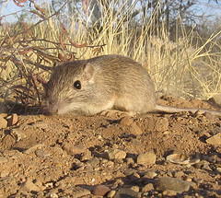
HHMI Pocket Mice Video

BACKGROUND
The rock pocket mouse (Chaetodipus intermedius) is a small rodent in the Heteromyidae family. Even though it looks very much like a mouse, pocket mice are more closely related to pocket gophers than to true mice. We show the classification and Heteromyidae phylogeny below:

Kingdom: Animalia
Phylum: Chordata
Class: Mammalia
Order: Rodentia
Family: Heteromyidae
Subfamily: Perognathinae
Genus and species: Chaetodipus intermedius

QUESTIONS
- Why do the pocket mice in the dark lava environment have white underbellies?

- What drives the differences in mouse fur color?

- How does a dark mouse appear in a population of light mice?

- What is a mutation?

- Are mutations bad?

- What does the Mc1R gene do?

- How do you get a population of dark colored mice?

- Did the mice on each of the dark lava flows have the same mutation?

- Is evolution a random process?

- Why would coat color matter to a nocturnal animal? (thinking question – not in video)

