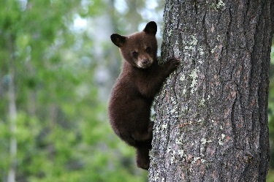
Name: _____________________________

The Bears are Back

http://wfcc.uconn.edu/BlackBearsinConnecticut.php
Use the link above to get onto the UCONN Wildlife and Fisheries Conservation Center website. Scroll down to “The Bears are Back” image link on the bottom of the page. From there, navigate the slides and fill in or answer the following questions.
Home Page:
1. Black bears scientific name is: _____________________________
2. Black bears are carnivores/herbivores/omnivores (circle one).
3. In Connecticut, the black bears range from ______________ to _______________ areas.

Established Range:
4. In 2015 which town in district 10 had more bear sightings? ________________________
5. Did any towns report 0 sightings of bears? _____________________
6. How many towns had over 75 sightings? __________________
7. Which town had the most sightings? How many? ________________________________
8. Where are the majority of sightings in CT? _______________________

Reported Incidents:
9. Between 2008 and 2012, ________ incidents of bears damaging property were reported to DEEP.
10. In your own words, define range as it pertains to biology.

11. Which areas are most likely to involve a bear conflict? ____________________________

12. Some of the conflicts include: trashcans, structural, livestock/pet, home entry, and vegetation damage.
Suggest what lead to these conflicts.

Trashcans

Structural

Livestock/Pet

Home Entry

Vegetation

Predicting Conflict:
13. List what factors are accounted for when considering bear-human conflict.

14. Risk prediction can be useful to anticipate ____________________________________________________________________________________.
A Quest for Hair:
15. To estimate the size and distribution of the CT black bear population, biologists set up ____________________________________________________________________________________.
16. Using your answer from question 15, explain how the hair is collected.

17. How high off the ground was the wire? ____________ WHY?

Corrals in Action:
18. How many corrals have been set up across northwest Connecticut? ___________________
19. How frequently was hair collected? ______________________
20. Why do you think the hair was collected that frequently?

21. As a biologist, how could you improve this method?

Getting to know Connecticut’s Bears:
22. What kind of information can we gather from the bear hair that is collected? How does this information help us?

23. In total _______ different bears were identified across northwestern Connecticut.
24. Click on Burlington as a town, a box should pop up. Record the number of SOWCUBS11, the number of SowCubs1215, and the CubChange.

25. What is the CubChange? What could influence this change?

Exurbia… Just Right
26. The highest concentration of bears is found in what region? ___________________

27. Based on the total bear density, rank the following from most bear dense to least bear dense.
Urban – Suburban – Rural – Exurban

28. Why would the bears be most dense in the area you listed in #27?

29. Click on either the “Get Bear Smart Society” or “Living with Wildlife Foundation” and list 2-3 facts you found useful.

