CARBOHYDRATES
LIPIDS
DEHYDRATION SYN.
HYDROLYSIS
MONOSACCHARIDES
DISACCHARIDES
POLYSACCHARIDES
FAT
PHOSPHOLIPIDS
CHOLESTEROL
STEROIDS
HORMONES
CHON
MACROMOLECULES
CH₂0
ENZYMES
GLUCOSE
SUCROSE
FRUCTOSE
LACTOSE
GALACTOSE
STARCH
CELLULOSE
GLYCEROL
3 FATTY ACIDS
GLYCOGEN
CELL MEMBRANE
PLANTS
ANIMALS
LIQUID
SOLID
HYDROPHILLIC
HYDROPHOBIC
4 FUSED RINGS
PLANT CELL WALL
SATURATED FAT
UNSATURATED FAT
OIL
BUTTER
LONG TERM ENERGY
INSULATION
QUICK ENERGY
STRUCTURE
CUSHION ORGANS
1:2:1
CH₂(very little O)
LIVER & MUSCLE

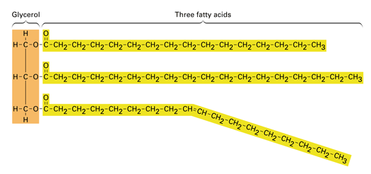
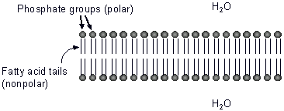

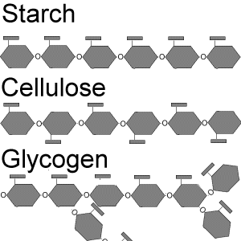

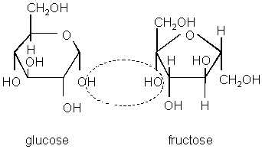
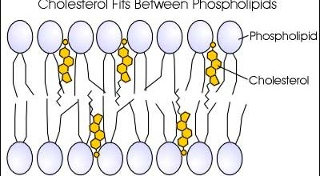
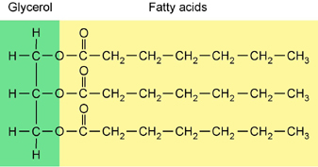
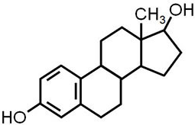
estrogen

